|  |
| --- |
| [Type the company name] |
| MATHS LAB ASSIGNMENT |
|  |
|  |
|  |
|  |

|  |
| --- |
|  |

SET 1:

1)Define a vector?

CODE:

import numpy as np

list = [15,12,23]

vector = np.array(list)

print("the vector is",vector)

OUTPUT:



2)Add 2 vectors using numpy?

CODE:

import numpy as np

list1 = [16, 22, 31, 25, 19]

list2 = [32, 22, 8, 3, 40]

vtr_1 = np.array(list1)

vtr_2 = np.array(list2)

print("we create vector from list1: ")

print("vtr1: ", vtr_1)

print("we create vector from list2: ")

print("vtr2: ", vtr_2)

vctr_add = vtr_1 + vtr_2

print("addition of two vector: ", vctr_add)

OUTPUT:

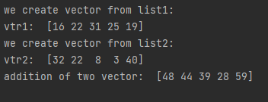

3)Subtract 2 vectors using numpy?

CODE:

import numpy as np

list1 = [20, 40, 19, 25, 42]

list2 = [1, 32, 7, 8, 32]

vtr_1 = np.array(list1)

vtr_2 = np.array(list2)

print("we create vector from list1: ")

print("vtr1: ", vtr_1)

print("we create vector from list2: ")

print("vtr2: ", vtr_2)

vctr_sub = vtr_1 - vtr_2

print("substraction of two vector: ", vctr_sub)

OUTPUT:

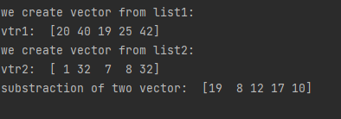

4)Multiply 2 vectors using numpy?

CODE:

import numpy as np

list1 = [7, 2, 3, 5, 7]

list2 = [5, 7, 2, 6, 9]

vtr1 = np.array(list1)

vtr2 = np.array(list2)

print("we create vector from list1: ")

print(vtr1)

print("we create vector from list2: ")

print(vtr2)

vtr_multi = vtr1 * vtr2

print("substract of two vector is: ", vtr_multi)

OUTPUT:

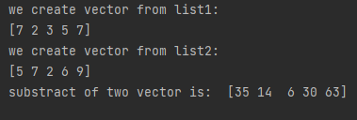

5)Divide 2 vectors using numpy?

CODE:

import numpy as np

list1 = [10, 15, 30, 50, 64]

list2 = [2, 3, 10, 5, 2]

vtr1 = np.array(list1)

vtr2 = np.array(list2)

print("we create vector from list1: ")

print(vtr1)

print("we create vector from list2: ")

print(vtr2)

vtr_div = vtr1 / vtr2

print("division of two vector is: ", vtr_div)

OUTPUT:

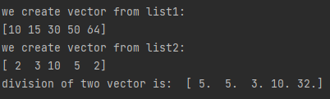

6)Find dot product of two vectors?

CODE:

import numpy as np

list1 = [14, 12, 13, 15, 17]

list2 = [5, 7, 2, 6, 2]

vtr1 = np.array(list1)

vtr2 = np.array(list2)

print("we create vector from list1: ")

print(vtr1)

print("we create vector from list2: ")

print(vtr2)

vtr_product = vtr1 . dot(vtr2)

print("dot product of two vector is: ", vtr_product)

OUTPUT:

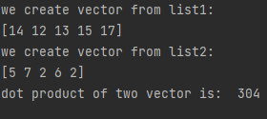

7)Perform vector scalar multiplication?

CODE:

import numpy as np

list1 = [3, 6, 9, 12]

vtr1 = np.array(list1)

print("we create vector from list1: ")

scalar_value = 5

print(vtr1)

print("scalar value: "+str(scalar_value))

vtr_scalar = vtr1 * scalar_value

print("multiplication of one scalar and vector is: ", vtr_scalar)

OUTPUT:

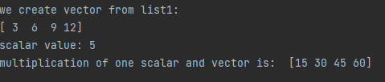

8)Find program for L1 norms and L2 norms?

CODE:

from numpy import inf

from numpy import array

from numpy.linalg import norm

arr = array([33, 25, 37, 45])

print(arr)

maxnorm = norm(arr,inf)

print("maxnorm:", maxnorm)

norm_l1 = norm(arr, 1)

print(norm_l1)

print("array we have is:", arr)

l2_norms = norm(arr)

print("l2_norms", l2_norms)

OUTPUT:

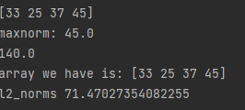

SET 2:

1)Define a matrix?

CODE:

import numpy as np

r = int(input("enter number of rows: "))

c = int(input("enter number of columns: "))

print("enter the entries in a (single line seperated by space):")

entries = list(map(int, input().split()))

matrix = np.array(entries).reshape(r, c)

print(matrix)

OUTPUT:

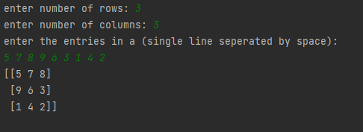

2)Add 2 matrix?

CODE:

x = [[3, 4, 9],

[2, 8, 7],

[6, 5, 4]]

y = [[9, 7, 8],

[6, 3, 4],

[2, 8, 3]]

result =[[x[i][j]+y[i][j] for j in range(len(x[0]))]for i in range(len(x))]

for r in result:

print(r)

OUTPUT:

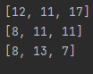

3)Substract two matrix?

CODE:

x = [[9, 8, 7],

[6, 5, 4],

[3, 2, 1]]

y = [[7, 4, 5],

[3, 3, 1],

[2, 1, 1]]

result =[[x[i][j]-y[i][j] for j in range(len(x[0]))]for i in range(len(x))]

for r in result:

print(r)

OUTPUT:

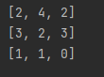

4)Find hadamard product of two matrix?

CODE:

import numpy as np

a = np.array([[3, 2, 5],

[5, 4, 7]])

b = np.array([[1, 2, 4],

[3, 4, 6]])

c = np.multiply(a, b)

print(c)

OUTPUT:

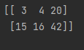

5)Divide two matrix?

CODE:

x = [[81, 78, 36],

[70, 43, 90],

[8, 24, 55]]

y = [[3, 4, 6],

[7, 2, 10],

[2, 12, 5]]

result =[[x[i][j]/y[i][j] for j in range(len(x[0]))]for i in range(len(x))]

for r in result:

print(r)

OUTPUT:

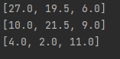

6)Find the product of two matrix?

CODE:

x = [[4, 9, 8],

[7, 3, 5],

[9, 5, 2]]

y = [[9, 8, 4],

[6, 5, 9],

[3, 4, 6]]

result =[[x[i][j]*y[i][j] for j in range(len(x[0]))]for i in range(len(x))]

for r in result:

print(r)

OUTPUT:

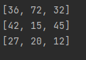

7)Perform vector matrix multiplication?

CODE:

import numpy as np

A = np.array([[5, 7],

[3, 4]])

d = np.array([[2],

[4]])

result = np.matmul(A, d)

print(result)

result = np.matmul(A, d)

print(result)

OUTPUT:

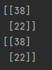

8)Perform scalar matrix multiplication?

CODE:

N = 3

def scalarProductMat(mat, k):

for i in range(N):

for j in range(N):

mat[i][j] = mat[i][j] * k

if __name__ == "__main__":

mat = [[2, 4, 6],

[5, 9, 3],

[4, 3, 7]]

k = 4

scalarProductMat(mat, k)

print("Scalar Multiplication of Matrix is : ")

for i in range(N):

for j in range(N):

print(mat[i][j], end=" ")

print()

OUTPUT:

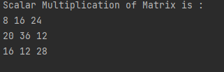

9)Define a 3*3 square matrix extract the main diagonal as vector?

CODE:

import numpy as np

row = int(input("enter number of rows:"))

col = int(input("enter number of cols:"))

print("enter the entries for matrix:")

num = list(map(int, input().split()))

matrix = np.array(num).reshape(row, col)

print(matrix)

geeks = matrix.diagonal()

print("diagonal vector:", geeks)

arr = []

def dia(matrix, row, col):

for i in range(0, row):

for j in range(0, col):

if(i==j):

m1=matrix[i][j]

arr.append(m1)

else:

m1=0

arr.append(m1)

return arr

OUTPUT:

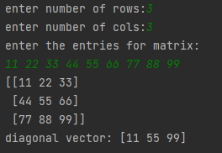

10)Create an identity matrix of order 4?

CODE:

def Identity(size):  
 for row in range(0, size):  
 for col in range(0, size):  
  
 if(row==col):  
 print("1 ",end=" ")  
 else:  
 print("0 ",end=" ")  
 print()  
size = int(input("enter the order of the matrix\n"))  
print("order of matrix is",size)  
Identity(size)

OUTPUT:

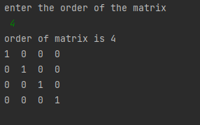

11)Find transpose of a matrix?

CODE:

def transpose(A,B):

for i in range(n):

for j in range(m):

B[i][j] = A[j][i]

import numpy as np

n = int(input("enter number of rows: "))

m = int(input("enter number of columns: "))

print("enter the entries in a (single line seperated by space):")

entries = list(map(int, input().split()))

A = np.array(entries).reshape(n, m)

print("A:",A)

B = [[0 for x in range(m)]for y in range(n)]

transpose(A,B)

print("Result matrix is B: ")

for i in range(n):

for j in range(m):

print( B[i][j], "", end="")

print()

OUTPUT:

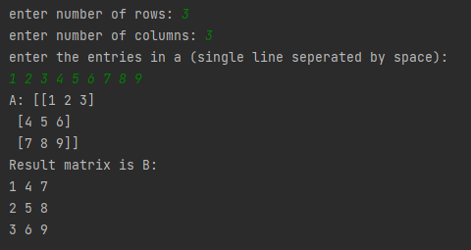

12)Inverse of a matrix?

CODE:

import numpy as np

n = int(input("enter number of rows:"))

m = int(input("enter number of columns:"))

print("enter the entries in a (single line seperate by space):")

entries = list(map(int, input().split()))

A = np.array(entries).reshape(n, m)

print("A:", A)

print(np.linalg.inv(A))

OUTPUT:

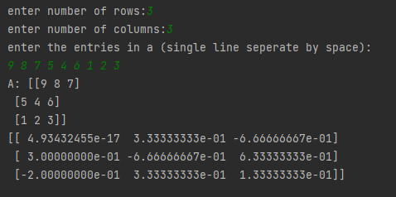

13)Print determinant of matrix?

CODE:

import numpy as np

n = int(input("Enter the order of matrix :"))

matrix=[]

print("Enter the elements of matrix :")

for i in range (n) :

for j in range (n) :

ele = int(input())

matrix.append(ele)

print("The matrix is")

matrix = np.array(matrix)

matrix= matrix.reshape(n,n)

determinant_matrix = np.linalg.det(matrix)

print(matrix)

print("The determinant of matrix is")

print(determinant_matrix)

OUTPUT:

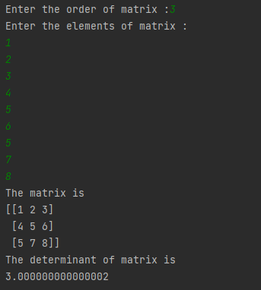

SET 3:

1)Create an orthogonal matrix?

CODE:

def is_orthogonal(Q, m, n):

if m != n:

return False

else:

for i in range(0, n):

for j in range(0, n):

sum = 0

for k in range(0, n):

sum = sum + round(Q[i][k] * Q[j][k])

if i != j and sum != 0:

return False

if i == j and sum != 1:

return False

else:

return True

Q = [[0.68567, 0.12975, -0.71626],

[0.14807, 0.93855, 0.31176],

[0.71269, -0.31982, 0.62433]]

if is_orthogonal(Q, 3, 3):

print("The given matrix is orthogonal")

else:

print("The given matrix is not orthogonal")

OUTPUT:



2)Print rank of matrix?

CODE:

import numpy as np

matrix = np.array([[2, 7, 9, 4],

[1, 3, 6, 7],

[3, 7, 2, 8],

[10, 12, 14, 11]])

print("rank of matrix:", np.linalg.matrix_rank(matrix))

OUTPUT:



3)Sparsity of matrix?

CODE:

import numpy as np

from scipy.sparse import csr_matrix

A=np.array([[1,0,0,0,0,0],[0,0,2,0,0,1],[0,0,0,2,0,0]])

print("Dense matrix representation:\n",A)

S=csr_matrix(A)

print("sparse matrix:\n",S)

B=S.todense()

print("Dense matrix:\n",B)

OUTPUT:

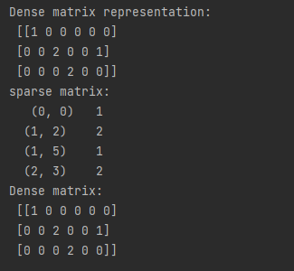

4)Print eigen values and eigen vectors of a matrix?

CODE:

import numpy as np

from numpy.linalg import eig

def Eigen(matrix):

Evalue, Evector = eig(matrix)

value = np.array(Evalue)

vector = np.array(Evector)

print(f"\nEigen Value Of The Matrix :\n\n {value}\n\n\nEigen Vector Of The Matrix :\n\n{vector}\n\n")

matrix = np.array([

[7, 9, 3],

[0, 3, 6],

[6, 4, 7]

])

Eigen(matrix)

print("\nMatrix = :")

for row in matrix:

print(row)

OUTPUT:

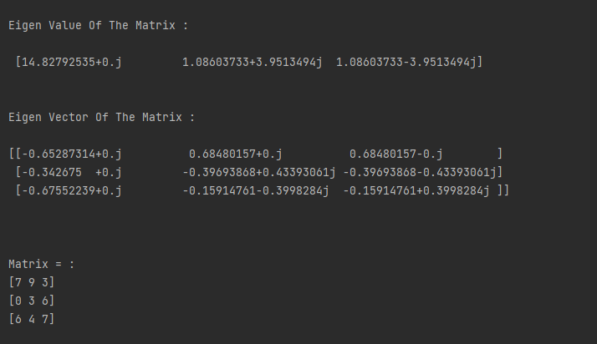

5)Calculate eigen values and eigen vectors of a matrix and reconstruct the matrix?

CODE:

from numpy import diag

import numpy as np

from numpy import dot

from numpy.linalg import inv

from numpy.linalg import eig

matrix = np.array([

[2,3,1],

[6,5,4],

[5,9,7]

])

print("\nMatrix = :")

for row in matrix:

print(row)

Evalues, Evectors = eig(matrix)

invEig = inv(Evectors)

Diagfrmvect = diag(Evalues)

rematrix = Evectors.dot(Diagfrmvect).dot(invEig)

print("\nRe-Constructed Matrix = :")

for row in rematrix:

print(row)

OUTPUT:

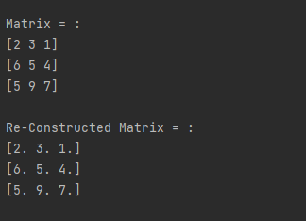

6)Define 5*2 matrix dataset ,split it into x and y components and print data set as scatterplot?

CODE:

import matplotlib.pyplot as plt

import numpy as np

matrix = np.array([

[7,79],[5,85],[9,88],[6,90],[8,75]]

)

x,y=np.split(matrix,2,axis=1)

plt.scatter(x, y)

plt.show()

OUTPUT:

